GLRI Phragmites Management Project Update
Aerial inventory and mapping of Phragmites in the project area was completed this spring, and final ground-truthing efforts are underway. Approximately 800 total acres of Phragmites has been mapped (Lower Green Bay from Duck Creek to Point au Sable; along the Fox River to De Pere dam; along the East River in Allouez/Bellevue, and along the lower reaches of Duck and Baird creeks) and will be targeted for treatment to begin this fall, pending landowner permission. Treatments will include chemical application of Imazapyr in early fall, followed by mowing in winter (where feasible). Sites include a mix of coastal wetlands, shoreline and riparian areas, roadsides, parks and trails, private residences, and commercial and industrial properties.

The Bay-Lake RPC is soliciting proposals [http://www.baylakerpc.org/media/97867/blrpc_phragmites_treatment_rfb.pdf] from certified contractors this month, and herbicide treatment is slated to begin in late August 2016 pending project permitting from Wisconsin DNR.

For more information about the BLRPC Phragmites project, contact Angela Kowalzek-Adrians or Amy Carrozzino-Lyon. When work begins, the Phragmites Information Hotline (920-430-0220) will be regularly updated with a recorded message about treatment schedule and progress.

New Funding Opportunity to Help Communities Mitigate the Impacts of Emerald Ash Borer (EAB)
In partnership with the Wisconsin DNR, East Central Wisconsin RPC, Northwest Wisconsin RPC, and Southeastern Wisconsin RPC, the Bay-Lake Regional Planning Commission has funding available to at help communities mitigate the impacts of Emerald Ash Borer (EAB) and prepare them for EAB invasion by diversifying their urban and community forests. The funding will help municipalities, counties and tribes to plant non-host trees.
Four to 80 projects, ranging from $1,000 to $20,000, are expected to be funded under this program. Eligible communities include those that are within the Wisconsin Great Lakes Basin and within an EAB quarantined county. The funding is made available through a FY2015 U.S. Forest Service Great Lakes Restoration Initiative (GRLI) grant received by the Bay-Lake Regional Planning Commission earlier this year.
Applications are due on August 17, 2016. For additional information visit: www.baylakerpc.org/eab-grant.
Sheboygan MPO Update
Commission staff has begun work on a 2016 Public Participation Plan Update for the MPO. The Sheboygan MPO Technical and Policy Advisory Committees offered various changes to the current plan and authorized a 30 day public consultation period on the plan update at their joint meeting in late May. Commission staff revised the current plan in response to comments received from members of the MPO advisory committees and updated the current plan to comply with recent Federal surface transportation legislation (MAP-21 and the FAST Act) in June. Commission staff also added a small number of additional contacts to the Public Participation Plan mailing list to comply with recent Federal surface transportation legislation and based on the suggestions of members of the MPO advisory committees in June. Members of the MPO advisory committees reviewed all of these changes at their joint meeting in late June. Commission staff initiated the 30 day public consultation period on the preliminary draft 2016 Public Participation Plan Update in late June, with everyone on the Public Participation Plan mailing list being notified and with the public consultation period announcement and the preliminary draft plan being posted to the MPO webpage.
Commission staff has started the process of preparing the update to the Sheboygan County Coordinated Public Transit – Human Services Transportation Plan. Commission staff contacted Shoreline Metro and the Sheboygan County Aging and Disability Resource Center (ADRC) to determine potential dates for a coordination meeting, which will occur the afternoon of August 16, 2016. Commission staff also began preparing background chapters of the plan. With assistance from Shoreline Metro and Sheboygan County ADRC staff, Commission staff updated the invitation list for the coordination meeting. Commission staff also prepared materials for this meeting, which will be mailed out to all invitees in late July.
The Commission transmitted two minor amendments to the 2016 – 2019 Sheboygan Metropolitan Planning Area Transportation Improvement Program (TIP) in late June. The minor amendments include: (1) small increases in the cost of the State Highway 42/Calumet Drive reconstruction project from Main Avenue to North 26th Street; and (2) completion of the Interstate Highway 43 sequencing and prioritization study from the Ozaukee County line to Interstate Highway 41 in Brown County in one year (previously, this project was to be completed in two years). The amendments were approved by the Commission in early June after being recommended for approval by the Sheboygan MPO Technical and Policy Advisory Committees in late May.
The Sheboygan MPO Technical and Policy Advisory Committees discussed and recommended approval of several minor amendments to the transit capital and elderly and disabled transportation capital components of the 2016 – 2019 TIP at their joint meeting in late June. The Commission will take action on these amendments at a meeting of its Executive Committee in late July.
The Commission’s GIS Coordinator has built an ArcGIS Online project related to the 2016 – 2019 TIP. The TIP webmap will display all of the projects covered from 2016 through 2019 (as amended) as well as the 2015 completed projects. Users will be able to pan around the Sheboygan metropolitan planning area and view the projects interactively with aerial photography or a simple base map and get a general description of the project. This is hopefully the first step in a more diverse array of webmaps related to MPO projects in future years. This web mapping was presented to members of the Sheboygan MPO Technical and Policy Advisory Committees at their joint meeting in late June.
Please contact Jeff Agee-Aguayo for additional information.

GIS Mapping Highlight for July

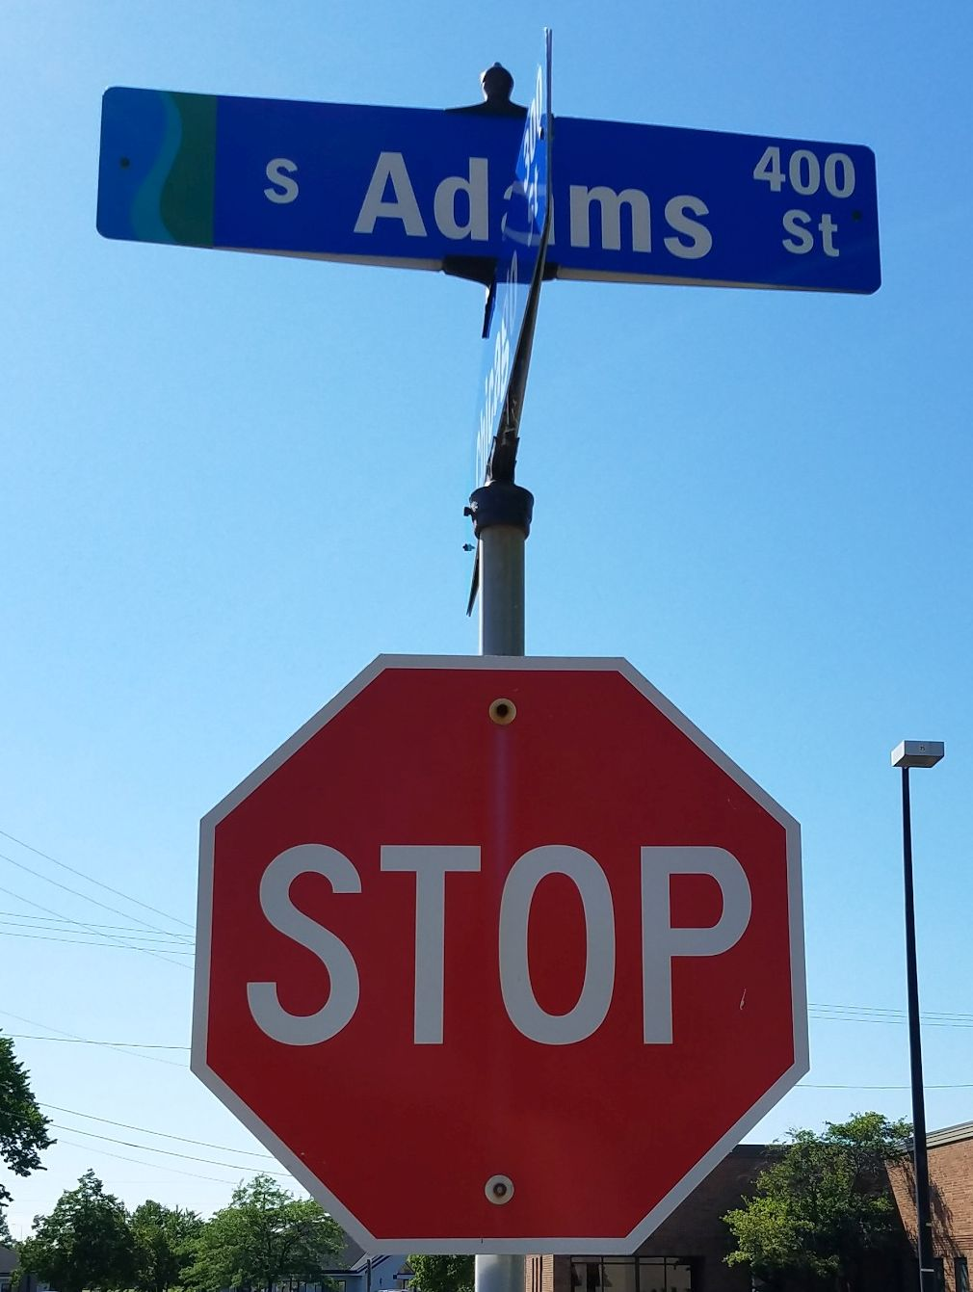
The Bay-Lake Regional Planning Commission is excited to offer a new sign inventory mapping project option for our communities. Sign inventory mapping is an important component of the MUTCD (Manual on Uniform Traffic Control Devices), allowing your community to be organized during your inventory or update process. Contact the Commission's GIS Department if your community is in need of a full inventory, an update to the inventory, or a streamlined online mapping option.

These are just a few of the many custom mapping projects that the Commission can assist communities with. Other map examples would include a location map for a grant application, a large air photo display, a series of maps for a public informational meetings, GIS analysis, and many others. The Commission's GIS Department will be happy to work with you to meet any of your mapping needs.

If you have any questions or comments, please contact Joshua Schedler.

Adopt a Highway Project
Commission staff give back to their community in many ways outside the workplace. One group project that was recently initiated was participation in the Wisconsin Department of Transportation’s “Adopt a Highway” program. Commission staff will be cleaning up the park-and-ride lot at U.S. Highways 41/141 and County Highway S in southern Oconto County three times between April 1 and November 1.

The picture below shows Commission staff who participated in the recent cleanup event on June 11th. A second cleanup will be scheduled for August.

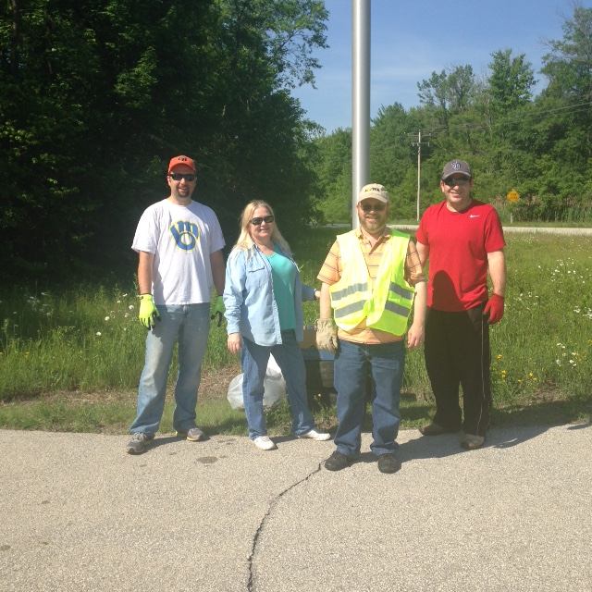
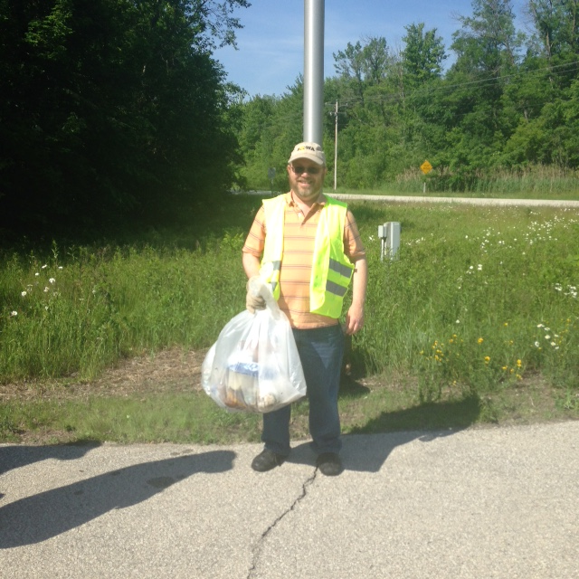

Upcoming Meetings and Events
Community Rating System (CRS) Workshop, Green Bay, August 23, 2016, 10-11:30 AM

http://www.baylakerpc.org/media/97756/january%20thru%20may%202016.pdf

Grants
The following is a list of upcoming grant opportunities and their due dates. Please contact the Commission if you have a project idea, or need assistance with preparing or administering a grant, or if you are interested in partnering with the Commission on a project.

Public Humanities Projects, August 10, 2016
Wisconsin Humanities Council Grants, August 15, 2016
C.D. Besadny Conservation Grants, September 1, 2016
National Endowment for the Arts Our Town Grants, September 12, 2016
Urban Innovation Grant, September 16, 2016
Captain Planet Foundation Educator Grants, September 30, 2016
ATC Community Tree Planting Program, September 30, 2016

